**Wilde, Oscar Fingal O'Flahertie Wills (1854-1900)**

**SUMMARY**

Oscar Wilde was an Irish playwright, essayist, author and poet, and one of Victorian England’s chief proponents of Aestheticism. His works are often characterised by the use of humorous paradox, which questions Victorian certainties of truth, value and morality. Wilde is best known today for his play *The Importance of Being Earnest* (1894), his novel *The Picture of Dorian Gray* (1890, revised 1891) and his imprisonment in 1895 on grounds of ‘gross indecency’ after a series of scandalous trials.

Individualism is central to Wilde’s philosophy, and many of his works challenge or ironise social conventions that seek to limit autonomy of personal expression. Wilde pre-figures the concerns of much twentieth-century Modernist literature in his critique of Realism, his scepticism regarding authentic selfhood and his often absurd dramatic mode. 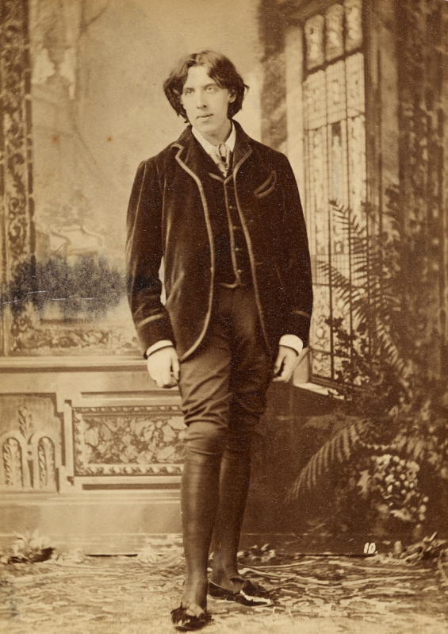

**BIOGRAPHICAL OVERVIEW**

Oscar Wilde, January 1882 (photographer unknown). (Url: http://www.bl.uk/britishlibrary/~/media/bl/global/english-online/collection-items-manual/u/n/k/unknown%20photographs%20b20147-80.jpg)

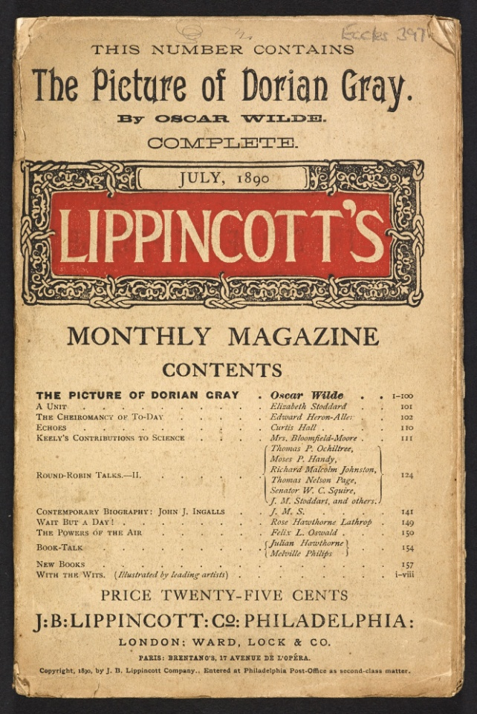Oscar Wilde was born in Dublin on 16 October 1854, the son of upper-middle class Anglo-Irish intellectuals. His earliest education was at the staunchly Protestant Portora Royal School in Enniskillen, before he progressed to Trinity College, Dublin in 1871. Wilde excelled as a student of Greek, and in 1874 was awarded a scholarship to read Classics at Magdalen College, Oxford. Here he was influenced by aesthetic theorists Walter Pater and John Ruskin. Having graduated with a double first, Wilde settled in London in 1879, where he soon set about cultivating an image as an aesthete and dandy.

In December 1881, Wilde sailed for the USA, where he spent the following year delivering around 150 lectures on a variety of aesthetic topics (‘The Decorative Arts’, ‘The House Beautiful’, etc.). Back in Europe, he lived in Paris from January to May 1883, fraternising with an avant-garde artistic community that included Paul Verlaine, Edgar Degas, and Émile Zola. In May 1884 he married Constance Mary Lloyd (1858–1898), with whom he 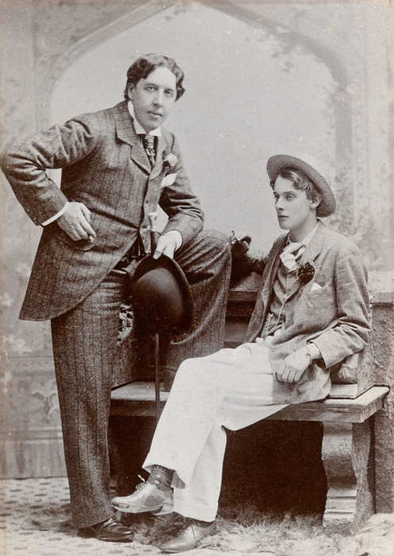had two sons, Cyril (1885) and Vivian (1886). Wilde established his reputation as a skilful essayist and short-story writer with ‘Lord Arthur Savile's Crime’ (1887), ‘The Decay of Lying’ (1889, revised 1891) and ‘The Portrait of Mr W. H.’ (1889, revised 1893). Controversy surrounded the publication of *The Picture of Dorian Gray* in 1890, and Wilde augmented his reputation for sedition with the anarchistic essay, ‘The Soul of Man Under Socialism’ (1891).

*The Picture of Dorian Gray* as first published in *Lippincott's Magazine,* 1890. (Url: http://www.bl.uk/britishlibrary/~/media/bl/global/english-online/collection-items-manual/l/i/p/lippincotts%20picture%20b20145-11.jpg)

Wilde enjoyed a string of theatrical successes with his society comedies *Lady Windermere's Fan* (1892), *A Woman of No Importance* (1893), *An Ideal Husband* (1893) and *The Importance of Being Earnest*. His Symbolist drama *Salome* (1891) proved more controversial: its sexualised Biblical subject matter ensured that a planned London performance in 1892 was banned by the Lord Chamberlain.

Oscar Wilde and Lord Alfred Douglas, Oxford, Spring 1893 (photographer unknown). (Url: http://www.bl.uk/britishlibrary/~/media/bl/global/english-online/collection-items-manual/u/n/k/unknown%20photographs%20b20147-85.jpg)

In February 1895, Wilde received a card from the Marquess of Queensberry (father of his lover, Lord Alfred Douglas) at his London club, accusing him of ‘posing as a somdomite [sic]’. Wilde pursued Queensberry with an accusation of criminal libel. In the trial that followed, Queensberry was acquitted on the basis of evidence that pointed to Wilde’s sexual relationships with working-class male youths. Wilde was ultimately found guilty of ‘gross indecency’, and sentenced to two years' penal servitude with hard labour.

Conditions in prison were brutal – at Pentonville, Wilde spent six hours a day on a treadmill and was forced to sleep on a plank bed. His works reflecting on his experience of imprisonment – *De Profundis* (1897) and *The Ballad of Reading Gaol* (1897) – are deeply moving. In May 1897, he emerged from prison not only physically and psychologically exhausted but also bankrupt, and immediately left for exile in France. Wilde spent the rest of his life moving between France and Italy, surviving on the financial support of friends. Never fully recovering his health, he died in Paris on 30 November 1900, aged 46.

**DRAMATIC WORKS**

Wilde began his career as a dramatist with *Vera, or the Nihilists* (1880), a melodramatic treatment of nihilist philosophy set in contemporary Russia. This was followed by *The Duchess of Padua* (1883), a revenge tragedy in blank verse, with clear echoes of Shakespeare and John Webster. Such works are generally considered to lack the linguistic wit and structural nuance of Wilde’s later plays and have been performed only infrequently since their composition.

Wilde’s society comedies of the 1890s proved much more successful, both critically and commercially. These plays work within the dramatic conventions of Victorian melodrama, but subtly subvert generic expectations to reveal the theatrical masquerade of aristocratic life in late-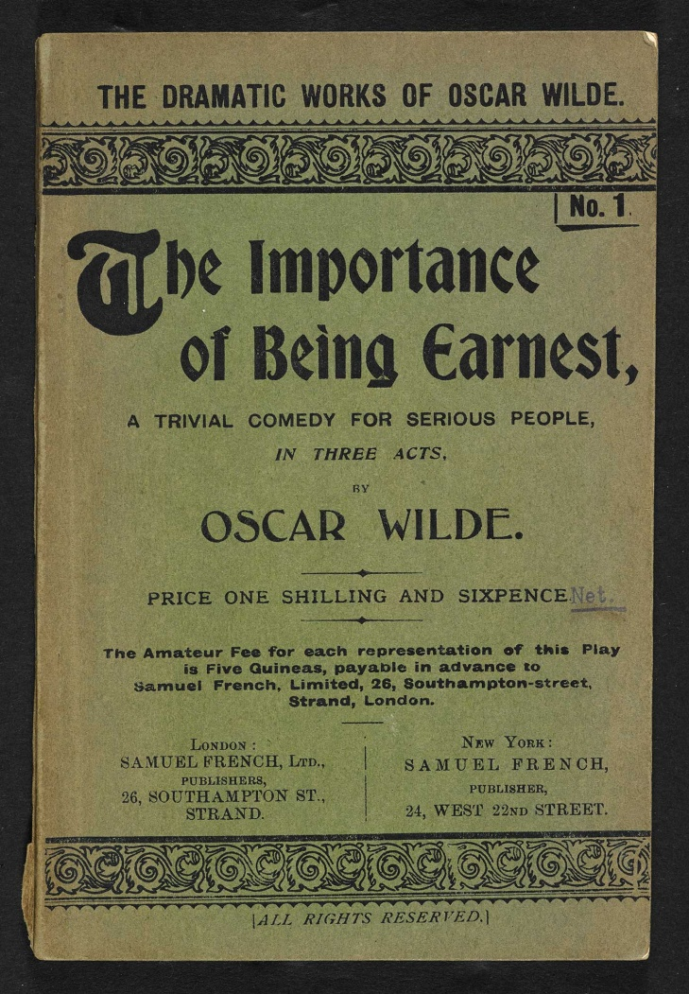Victorian England. The plots of both *Lady’s Windermere’s Fan* and *A Woman of No Importance* revolve around the familiar dramatic trope of a woman with a secret past. *An Ideal Husband* centres on the blackmail of a prominent politician. While Wilde’s plays show the influence of Henrik Ibsen in their preoccupation with moral hypocrisy and social intrigue, they generally reject dramatic Realism in favour of an ironic detachment which mocks society’s underlying values. Wilde’s characters – especially his dandy figures – often communicate in an epigrammatic language that seems designed to hide as much as it reveals.

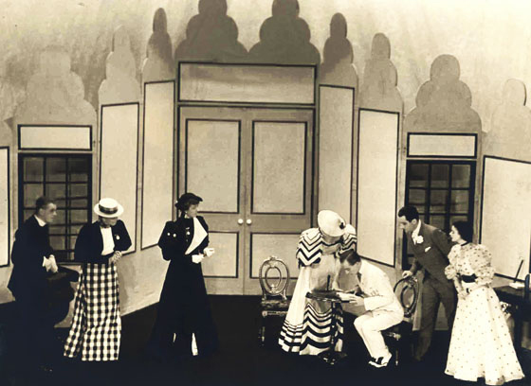Wilde’s ‘farcical comedy’, *The Importance of Being Earnest* further heightens this sense of subversive playfulness. In its rigid formal patterning, playful dramatic parody and delight in verbal paradox, Wilde’s play continually undermines any moral seriousness in order to expose the vacuous nature of social convention. The play’s plot concerns the attempts of middle-class Jack (posing under the alias Ernest) to marry the aristocratic Gwendolen, in the face of opposition from her mother, Lady Bracknell. Wilde enhances the stereotypical qualities of these stock characters – the young suitor, the naïve ingénue, the domineering dowager – to absurd comic effect, suggesting that individual personality is a matter not of sincerity and depth but rather of superficial performance.

Set design for Act III of *The Importance of Being Earnest*, directed by Nigel Playfair at the Lyric Hammersmith in 1930 (photographer unknown). (Url: http://www.vam.ac.uk/users/sites/default/files/album_images/58922-large.jpg)

Acting edition of *The Importance of Being Earnest*, 1895. (Url: http://www.bl.uk/britishlibrary/~/media/bl/global/english-online/collection-items-more/w/i/l/wilde-oscar-acting-b20129-68.jpg)

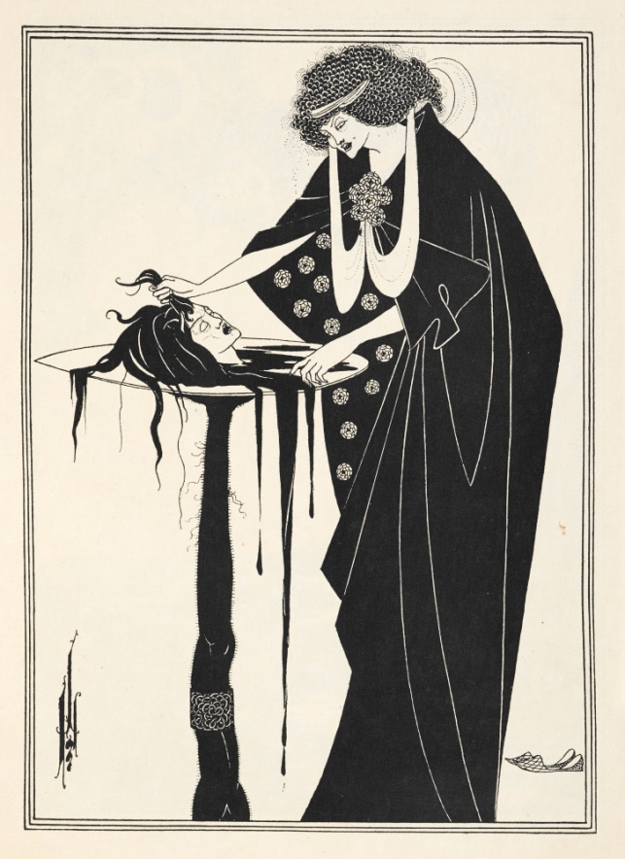Wilde’s experimental drama *Salome* – originally written in French in 1891 and first performed in Paris in 1896 – explores similar ideas of artificiality. The play follows the Biblical story of Salome’s dance of the seven veils and the subsequent decapitation of John the Baptist. Influenced by the Symbolist verse of Stéphane Mallarmé, the play’s repeated hypnotic phrases and patterns of imagery (in Wilde’s words) ‘bind it together like a piece of music with recurring motifs’. Wilde attempts to move beyond the representational quality of language by privileging the *sound* of the spoken text. The play’s perverse eroticism and exotic and archaic imagery are all contribute to its insistent anti-Realism. Aubrey Beardsley’s illustrations for the English edition of 1894 vividly evoke the destructive sexual obsession that would see Salome become the archetypal *femme fatale* of the *fin de siècle*. The play is perhaps best known today by way of Richard Strauss’s operatic adaptation of 1905, one of the seminal works of musical modernism.

Salome with the head of John the Baptist, Aubrey Beardsley, 1894. (url: http://www.bl.uk/britishlibrary/~/media/bl/global/english-online/collection-items-manual/b/e/a/beardsley-aubrey-aubrey-b20139-96.jpg)

**SHORT STORIES AND OTHER FICTIONS**

Wilde published several collections of short stories, ranging from Gothic satire (‘The Canterville Ghost’ [1887]) to fairy tale (‘The Happy Prince’ [1888]) to religious parable (*Poems in Prose* [1894]). Wilde’s stories often evoke the narrative simplicity of oral storytelling, whilst complicating and subverting the traditional moralising of such tales through the subtle use of irony and parody. ‘The Portrait of Mr. W.H.’, more self-consciously sophisticated in style, explores the identity of the dedicatee of Shakespeare’s Sonnets, tracing a tentative history of Platonic love between men across the centuries. The story pivots around a forged portrait of a beautiful young man, a symbol through which Wilde explores questions of authentic identity and the difficulty of artistic interpretation.

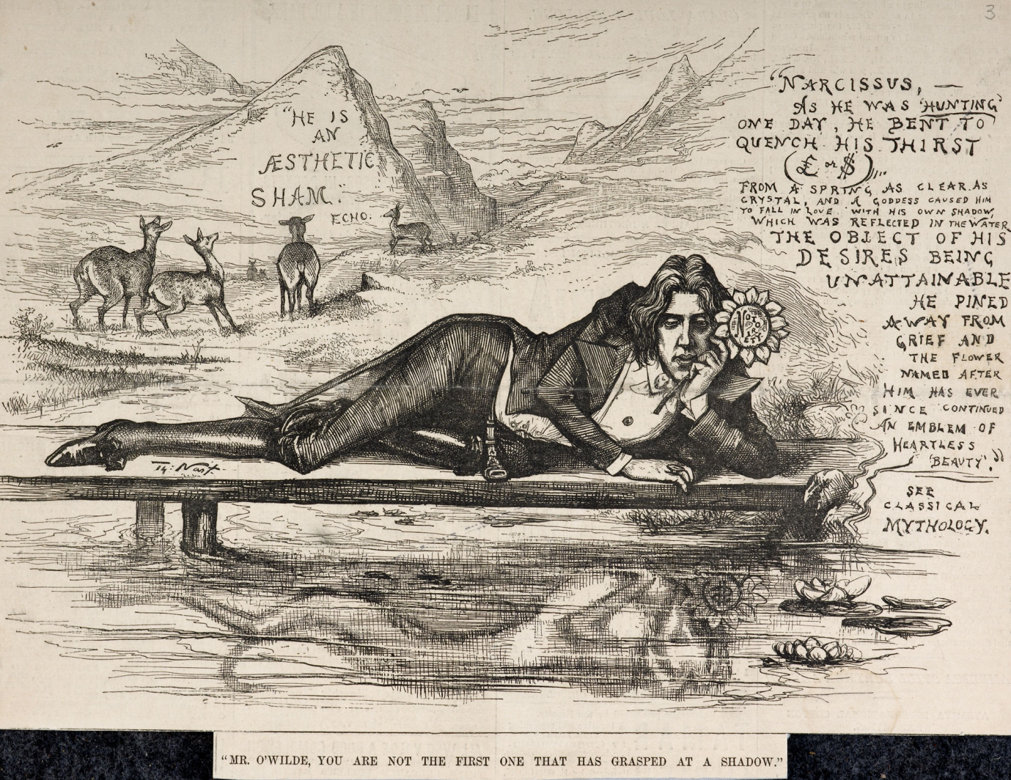

Caricature of Wilde as Narcissus by James Edward Kelly (1855–1933) in The Fortnightly Review of July 1894. Wilde's "prose poem" of that year, *The Disciples*, had dealt with this myth. (Url: http://www.bl.uk/britishlibrary/~/media/bl/global/english-online/collection-items-manual/k/e/l/kelly-james-oscar-c13590-69.jpg)

A portrait is similarly central to the plot of Wilde’s only novel – *The Picture of Dorian Gray* – in which a beautiful aesthete maintains his youthful good looks, whilst his portrait is instead marked by the outward signs of his moral decrepitude. The novel’s often ornate style and pervasive concern with the corrupting potential of Aestheticism is much influenced by Joris-Karl Huysmans’ novel of decadent excess, *À Rebours* (1884). Wilde purposefully leaves the details of Dorian’s immorality ‘vague and indeterminate’, though the novel was nevertheless understood by some contemporary reviewers to suggest homosexual misdeeds, and was removed from sale by W.H. Smith – a major distributor – on grounds of indecency.

**CRITICAL AND AUTOBIOGRAPHICAL PROSE**

Wilde’s critical and autobiographical prose works contain the clearest expression of his artistic and social philosophy. ‘The Decay of Lying’ – a dialogue between two aesthetes – challenges the validity of the dominant mode of Realism in late-Victorian art. Wilde refutes the idea that the role of art is to imitate nature; rather, he suggests that our perception of nature is frequently a product of art itself. Another dialogue, ‘The Critic as Artist’ (1891), concerns the function of artistic criticism. Rejecting the ‘disinterestedness’ of Matthew Arnold and instead embracing Walter Pater’s Impressionism, Wilde argues that criticism must necessarily be a subjective act of individual creativity.

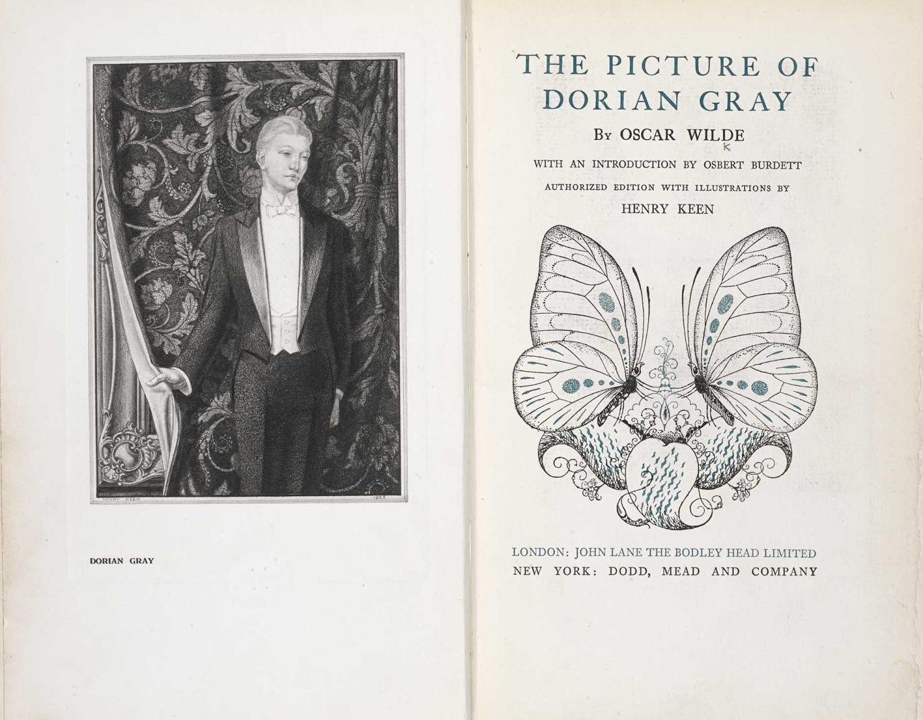‘The Soul of Man Under Socialism’ is Wilde’s most developed exposition of the value of individualism in society. Only socialism, Wilde suggests, will ‘relieve us from the sordid necessity of living for others’. In a wide-ranging discussion, Wilde attacks the manner in which private property distorts selfhood and espouses the value of art in propagating self-expression. *De Profundis* – a long letter addressed to Lord Alfred Douglas, though never sent – was written by Wilde during the course of his imprisonment. The letter is an often profound meditation on Wilde’s sense of his own artistry, the spiritual degradation caused by his imprisonment and the nature of suffering. The moral seriousness of the letter suggests a reversal of the apparent flippancy of much of his earlier writing. If Wilde previously held that ‘a little sincerity is a dangerous thing’, he now concludes that ‘the supreme vice is shallowness’.

Aside from these lengthier prose works, Wilde is well known for his witty epigrams – examples of which can be found in ‘Phrases and Philosophies for the Use of the Young’ (1894) and in the ‘Preface’ to *The Picture of Dorian Gray*.

Edition of *The Picture of Dorian Gray* from 1925, with illustrations by Henry Keen (1871–1935). (Url: http://www.bl.uk/britishlibrary/~/media/bl/global/english-online/collection-items-more/w/i/l/wilde-oscar-henry-b20128-71.jpg)

**POETRY**

Much of Wilde’s poetry is heavily influenced by his poetic forebears – Shakespeare, John Keats, Lord Byron, Dante Gabriel Rossetti, Algernon Charles Swinburne and William Morris, among others. When Wilde presented his volume *Poems* (1881) as a gift to the Oxford Union, it was rejected on grounds of plagiarism – and critical debate continues as to whether Wilde’s poetic style is best understood as a seditious challenge to ideas of authorial authenticity, or merely derivative. Wilde’s poetic output ranges from conventional Victorian occasional verse – for example, ‘Ave Imperatrix’ (1880) on the war in Afghanistan – to impressionistic works which actively refuse such political engagement.

*The Ballad of Reading Gaol* eschews the elaborate rhyme schemes and sensuous imagery of Wilde’s earlier verse to present in a stark and unadorned fashion the story of a man condemned to be executed. Written soon after Wilde’s release from prison, it was first published in February 1898 under Wilde’s Reading prison number, C.3.3. The poem moves between the abstract nature of ‘Man’s grim Justice’ and the specific story of a prisoner who ‘killed the thing he loved’, combining philosophical reflection with a didactic plea for penal reform.

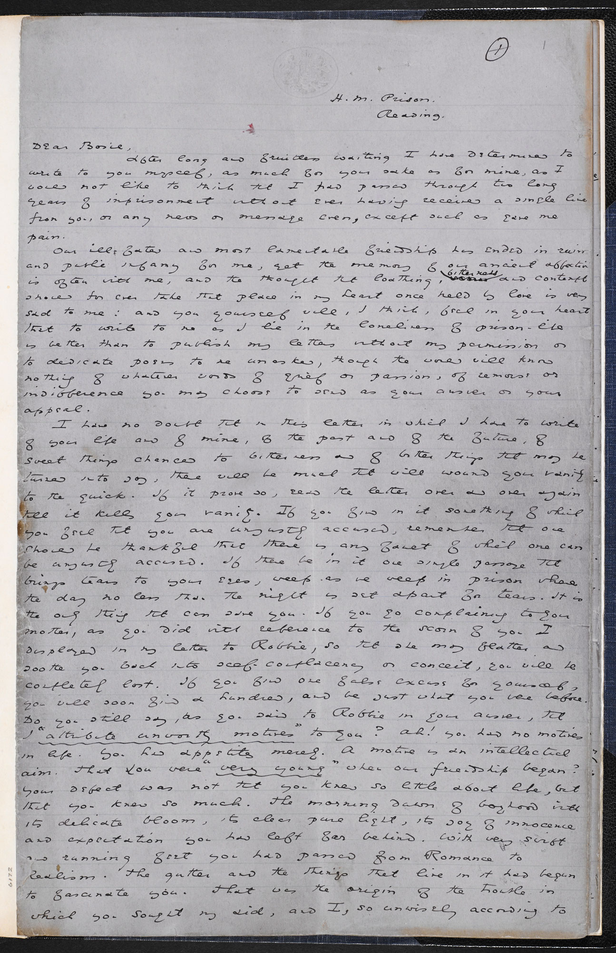

Manuscript of *De Profundis*, 1897. (Url: http://www.bl.uk/britishlibrary/~/media/bl/global/english-online/collection-items-manual/w/i/l/wilde-oscar-deprofundis-b20146-19.jpg)

**LIST OF WORKS**

***Collected works***

Wilde, O. (7 vols, 2000-present) *The Complete Works of Oscar Wilde*, eds. R. Jackson and I. Small, Oxford: Oxford University Press.

***Major works in order of composition***

*The Happy Prince and Other Tales* (1888)

‘The Decay of Lying’ (1889, revised 1891)

‘The Portrait of Mr. W.H.’ (1889, revised 1893)

*The Picture of Dorian Gray* (1890, revised 1891)

‘The Soul of Man Under Socialism’ (1891)

*Intentions* (including ‘The Critic as Artist’) (1891)

*Lord Arthur Savile's Crime and Other Stories* (1891)

*Salome* (1891)

*Lady Windermere’s Fan* (1892)

*A Woman of No Importance* (1893)

*An Ideal Husband* (1893)

*The Importance of Being Earnest* (1894)

*De Profundis* (1897)

*The Ballad of Reading Gaol* (1897)

**References and further reading**

Ellmann, R. (1987) *Oscar Wilde*, London: Hamish Hamilton.

Eltis, S. (1996) *Revising Wilde: Society and Subversion in the Plays of Oscar Wilde*, Oxford: Clarendon Press.

Robbins, R. (2011) *Oscar Wilde*, London: Continuum.

Sammells, N. (2000) *Wilde Style: The Plays and Prose of Oscar Wilde*, Harlow: Longman.

Sinfield, A. (1994) *The Wilde Century: Effeminacy, Oscar Wilde and the Queer Movement*, New York: Columbia University Press.

**Fraser Riddell**Durham University  
May 2015